**INDEX**

|  |  |  |
| --- | --- | --- |
| **S No.** | **TOPIC** | **Page No.** |
| 1 | DFES Agent creation | 2 |
| 2 | POSTMAN COLLECTION | 4 |
| 3 | Bucket Creation in GCP | 9 |
| 4 | Cloud function Creation | 13 |
| 5 |  |  |
| 6 |  |  |
| 7 |  |  |
|  |  |  |
|  |  |  |
|  |  |  |
|  |  |  |
|  |  |  |
|  |  |  |
|  |  |  |
|  |  |  |
|  |  |  |
|  |  |  |
|  |  |  |
|  |  |  |
|  |  |  |
|  |  |  |
|  |  |  |
|  |  |  |
|  |  |  |
|  |  |  |
|  |  |  |
|  |  |  |
|  |  |  |
|  |  |  |
|  |  |  |
|  |  |  |
|  |  |  |
|  |  |  |
|  |  |  |
|  |  |  |

**DFES Agent creation**

1. Access the below URL

<https://dialogflow.cloud.google.com/>

1. The below screen will appear and you can see the create agent button in the left bottom of the screen.

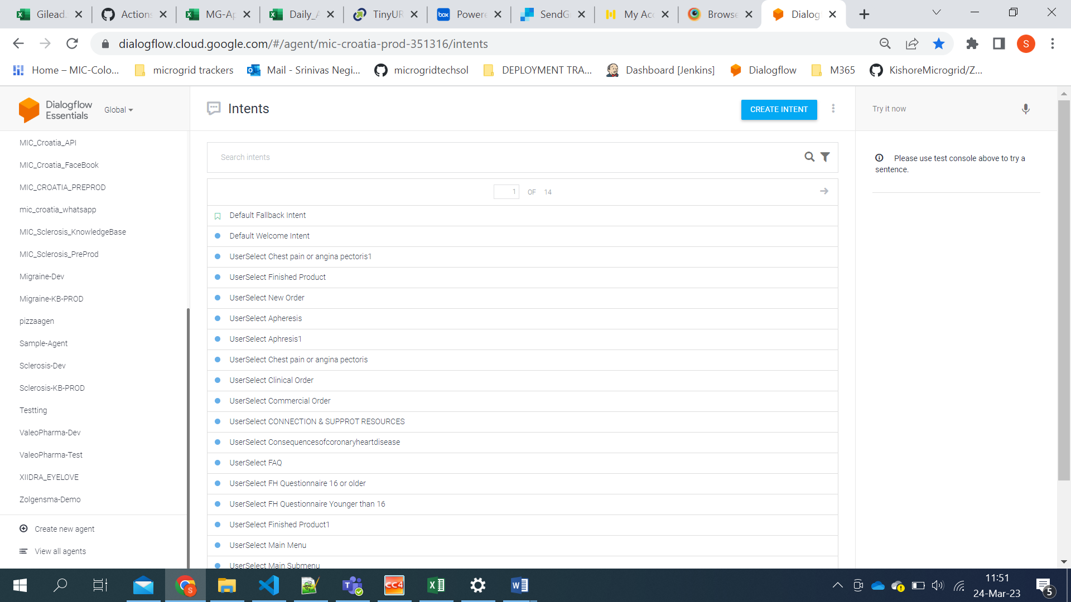

1. After clicking on the create agent button you can see the

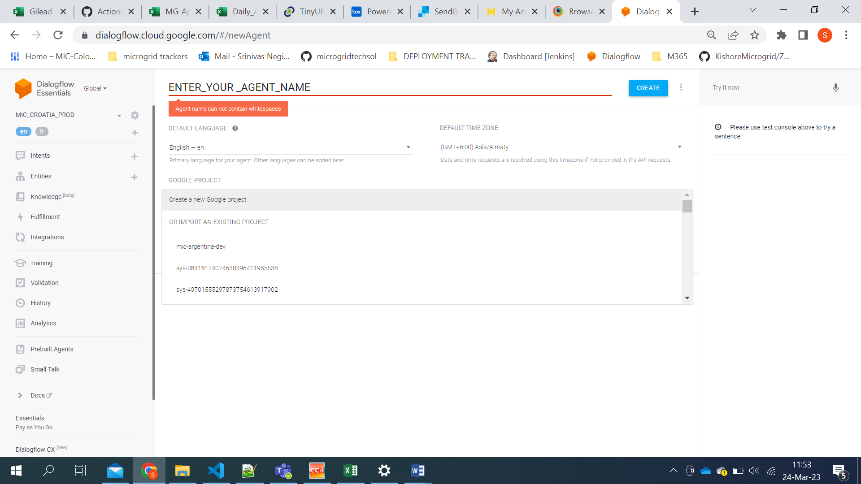

Default Language & Default Time zone are selected according to the project details.

And we need to connect to the project we want. You can see the project ID in the dropdown.

By clicking on the project id the agent will connect with the particular project.

**Note:**

1. Agent name should not contain white space.
2. We can create only one Agent for one project.

**POSTMAN COLLECTION**

1. Go tothe integrations part at the required agent. Then we can find wedemo option.

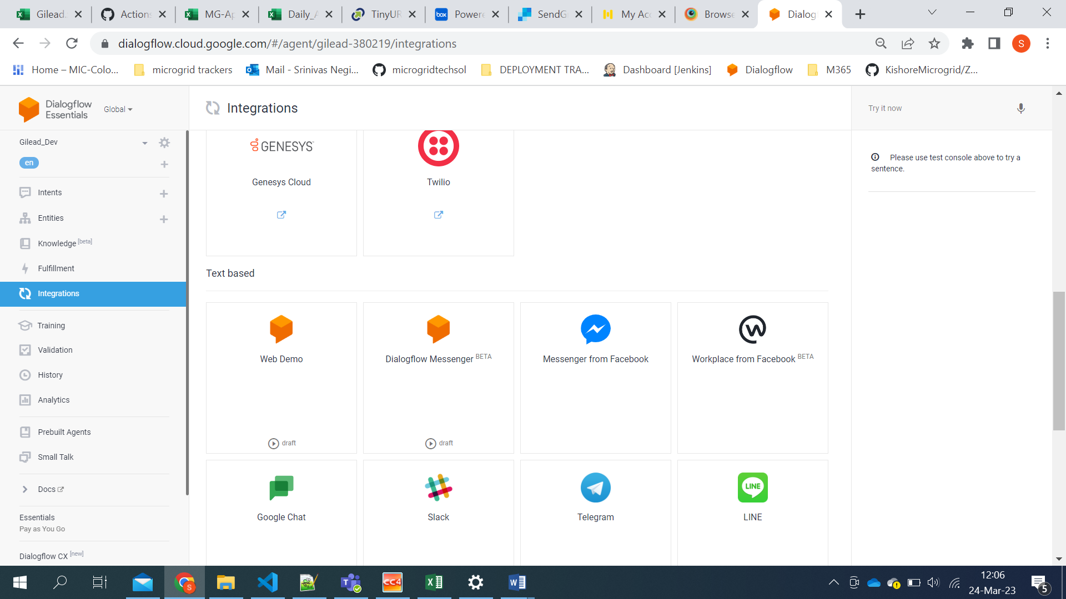

1. Click on the webdemo option and copy the URL shown on screen.

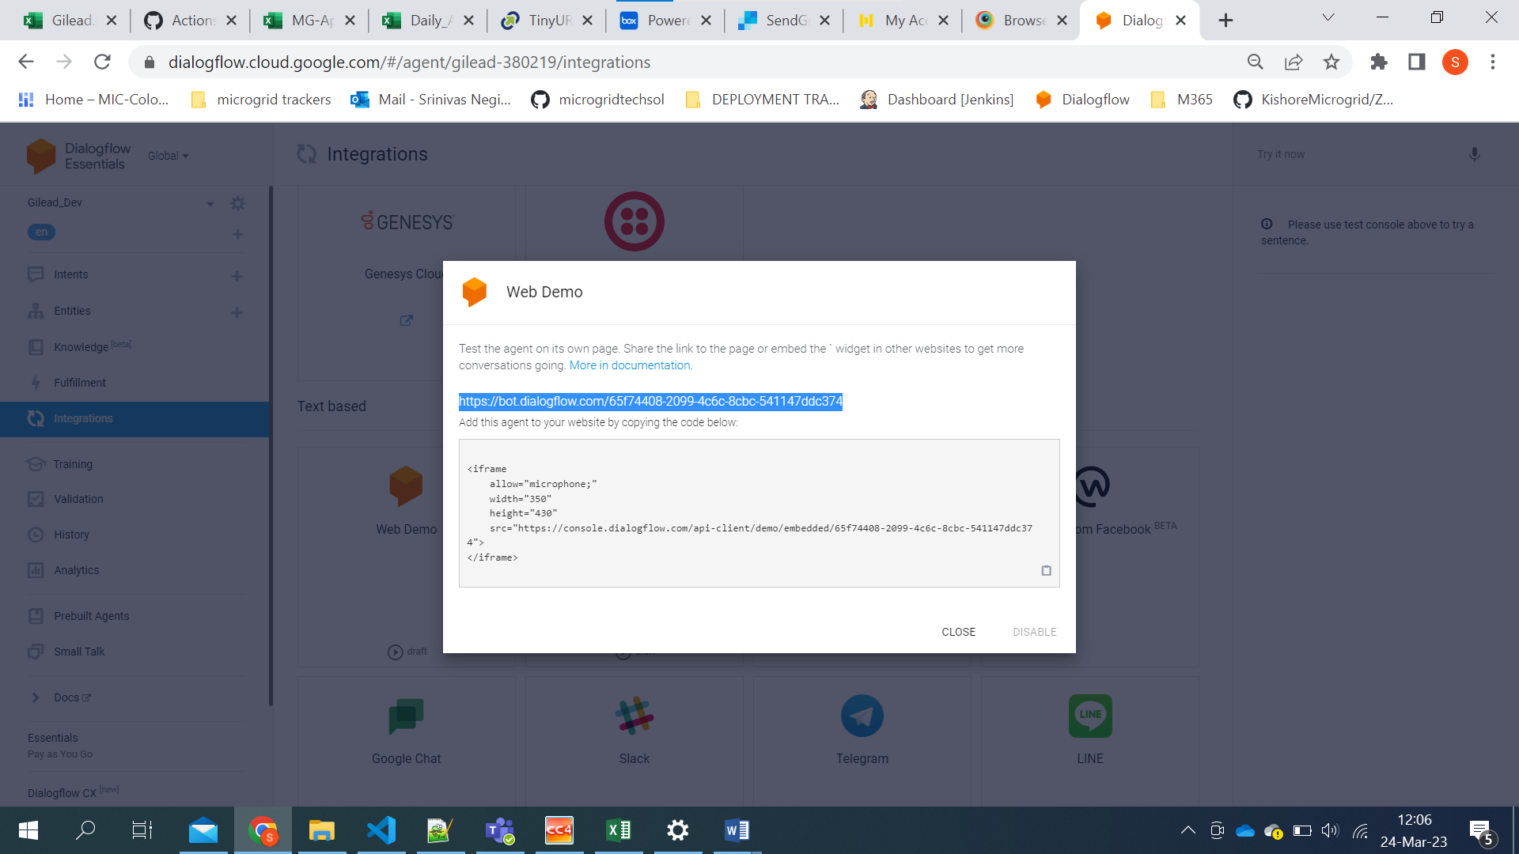

1. Access the URL from a browser and inspect it.

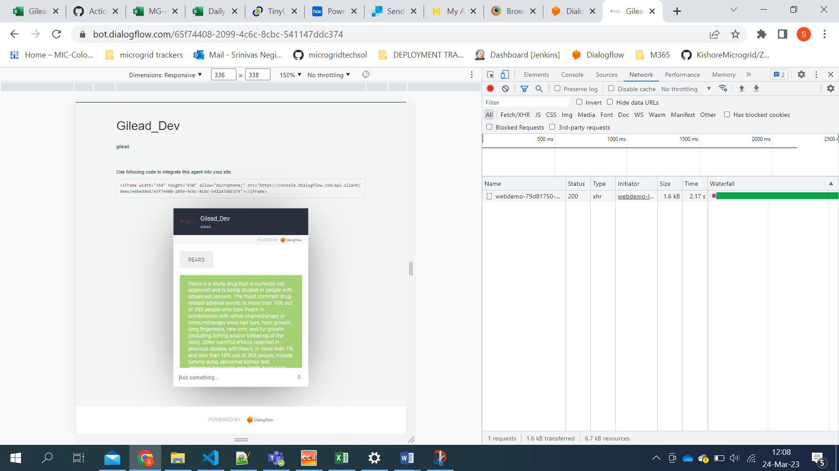

1. Now try to give any question in knowledgebase to see the response.
2. Go to the network section and see the response. Click on the response and go to the Headers section.

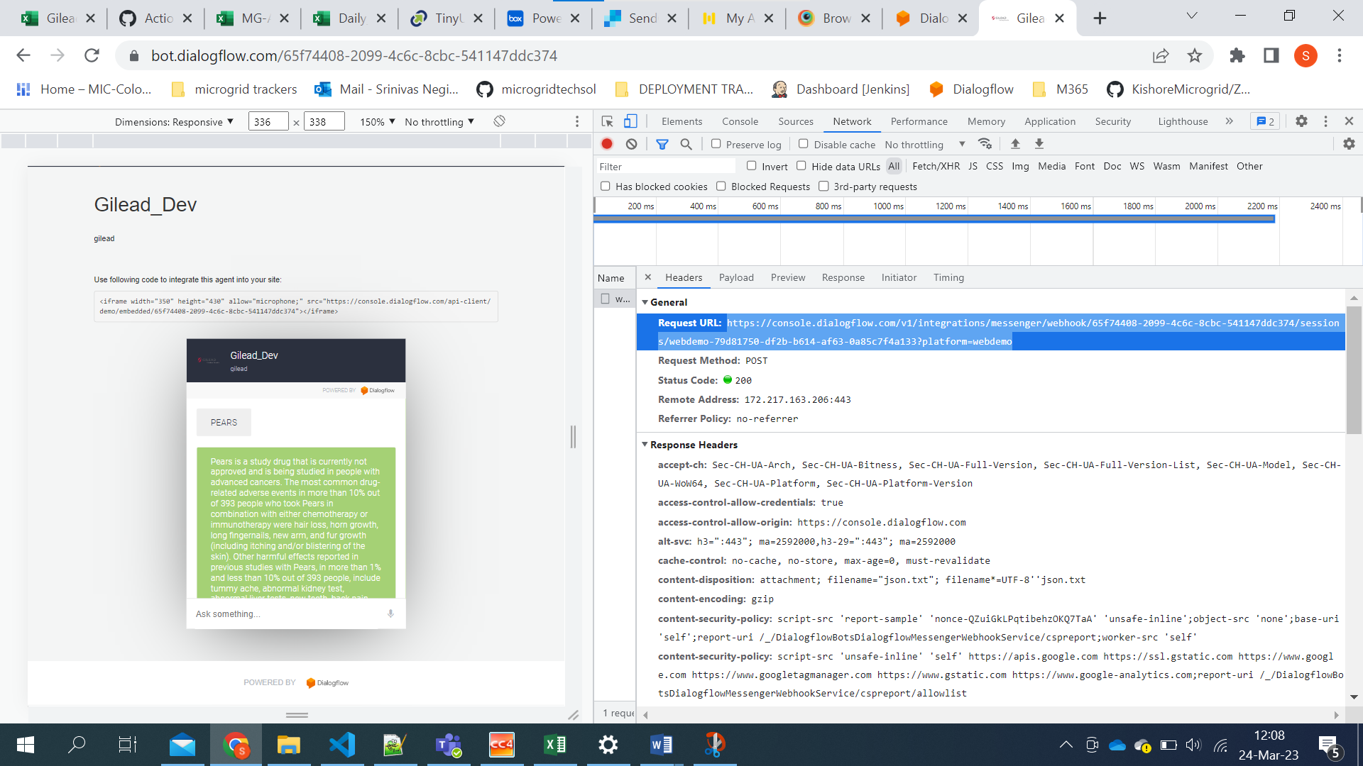

1. You will get a Request URL(API URL) as shown in the above screenshot. Copy the URL and navigate to postman application.

**HOW TO CREATE A NEWPOSTMAN**

1. Click on the New button to create a new postman collection.

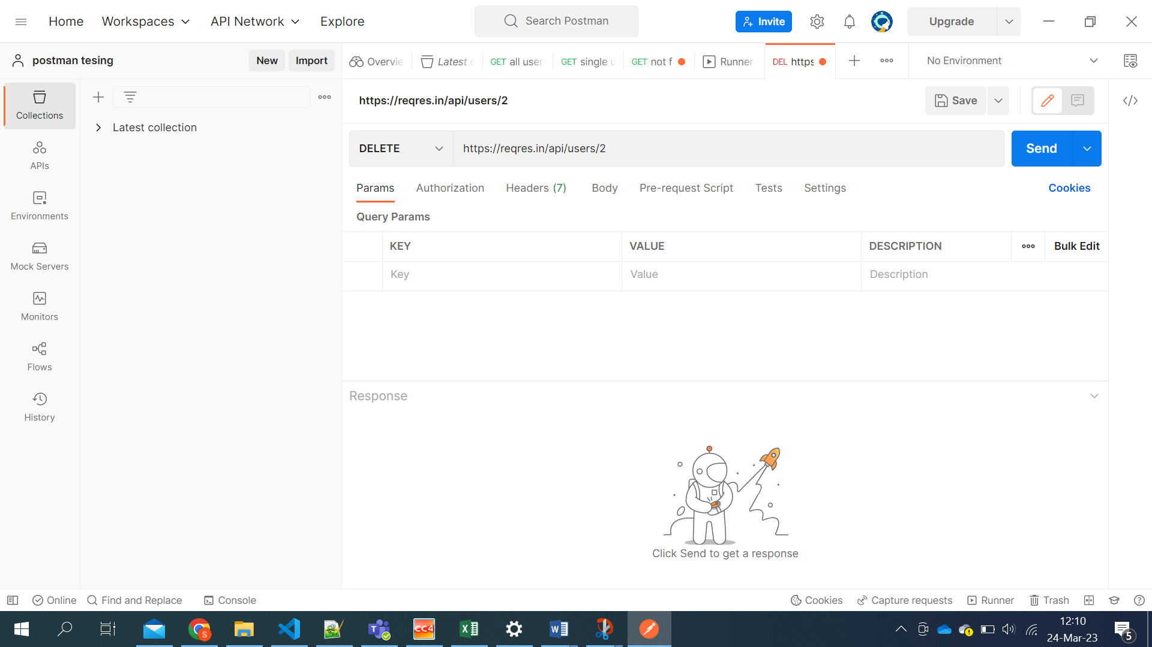

1. Now click on the HTTP request.

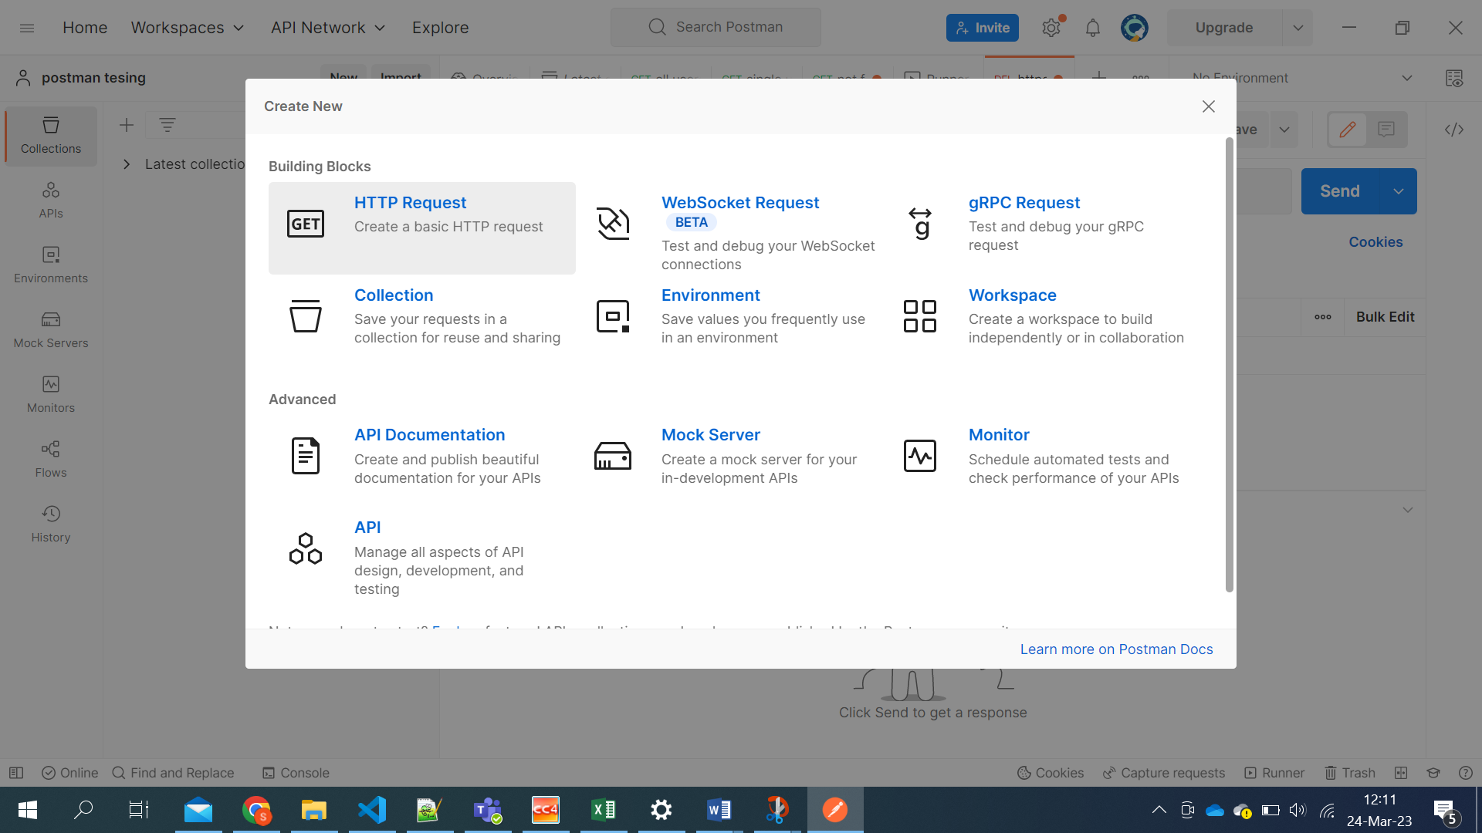

1. Paste the API URL which you have copied in the Dialogflow. Change the option form get to post.

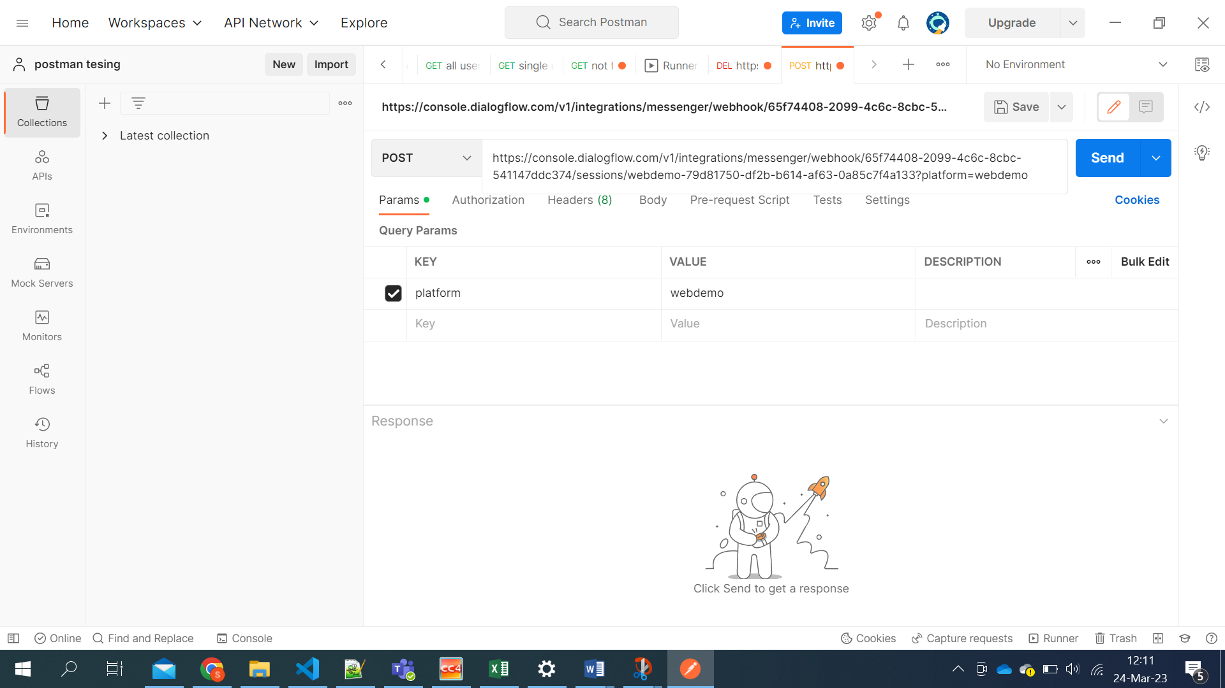

1. You will get a request payload in the inspect section.

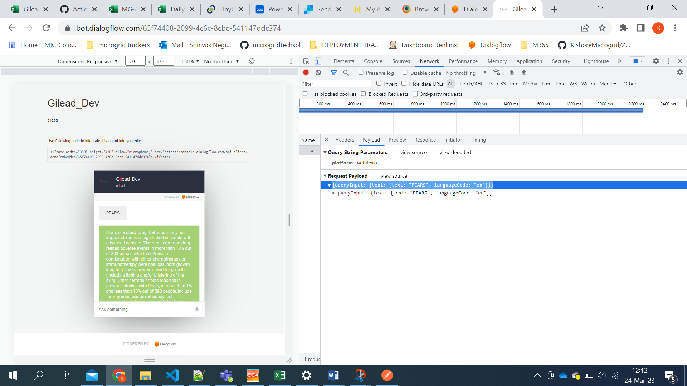

1. Copy the payload and paste in body section.

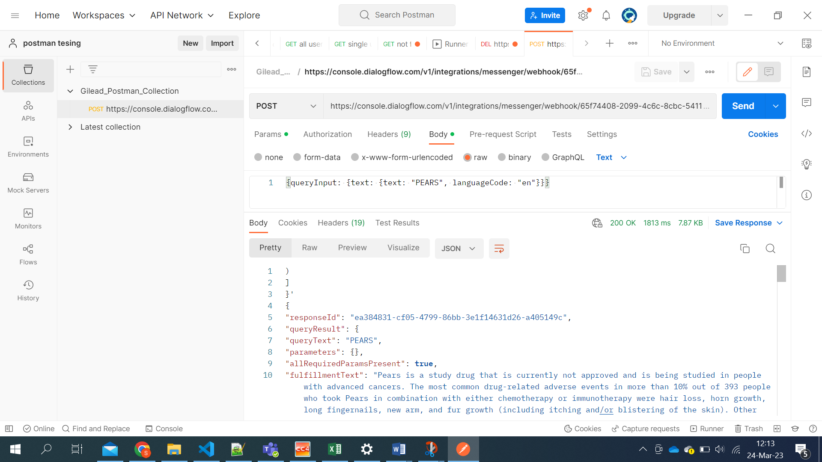

1. Save the request in the postman collection.

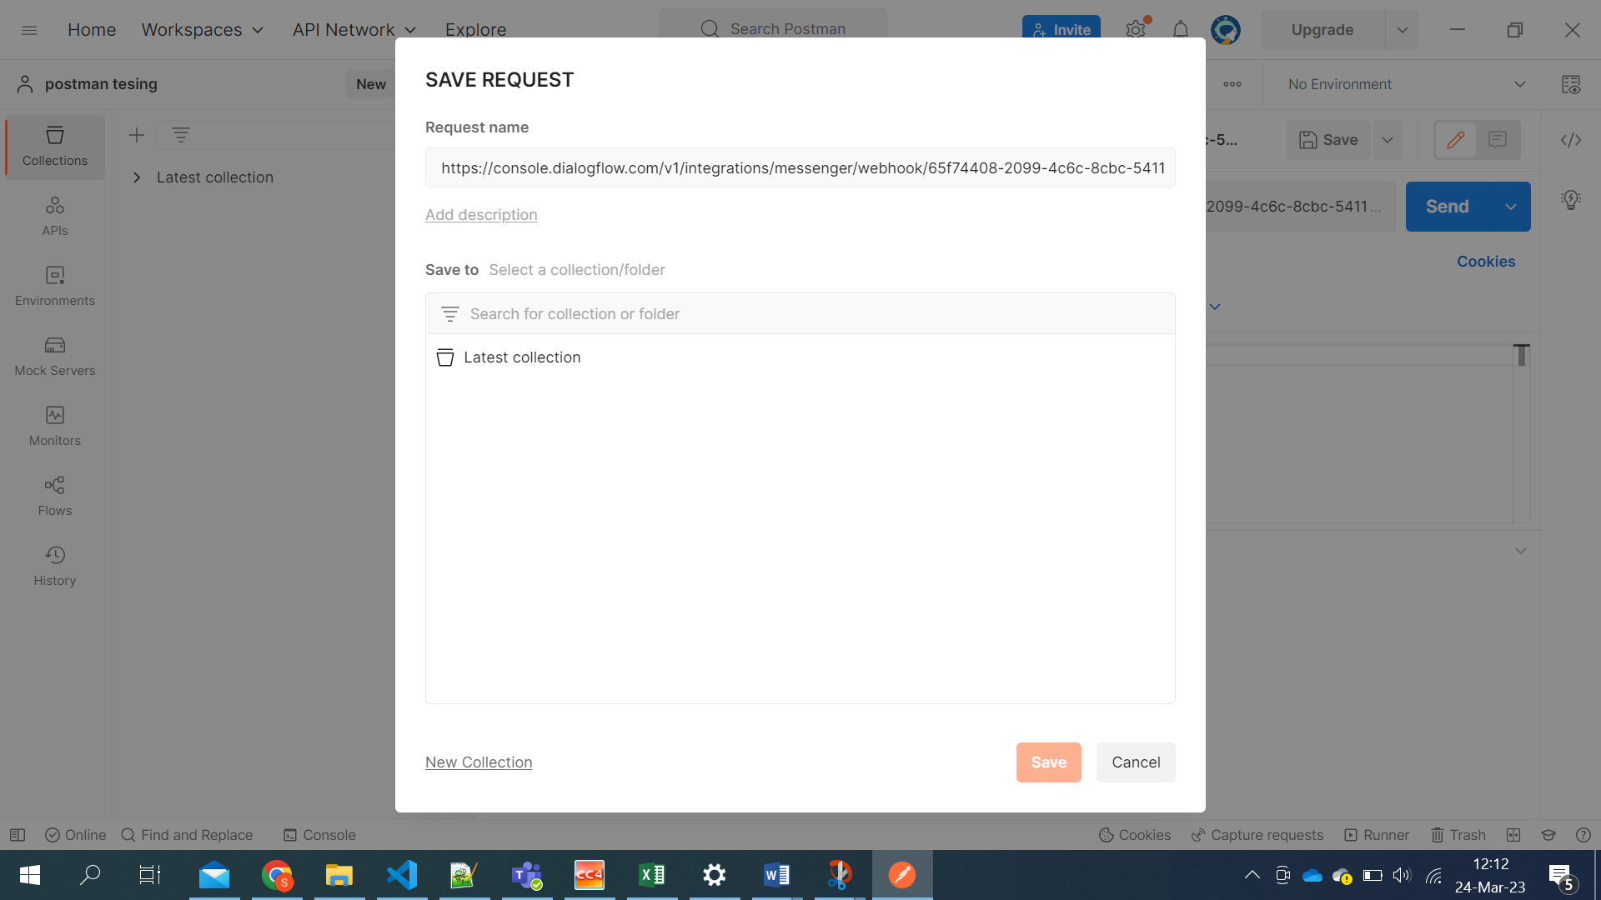

1. Now you can click on the send button and will get a intent response.

**BUCKET CREATION**

1. Access the cloud console and go to cloud storage service from the project.

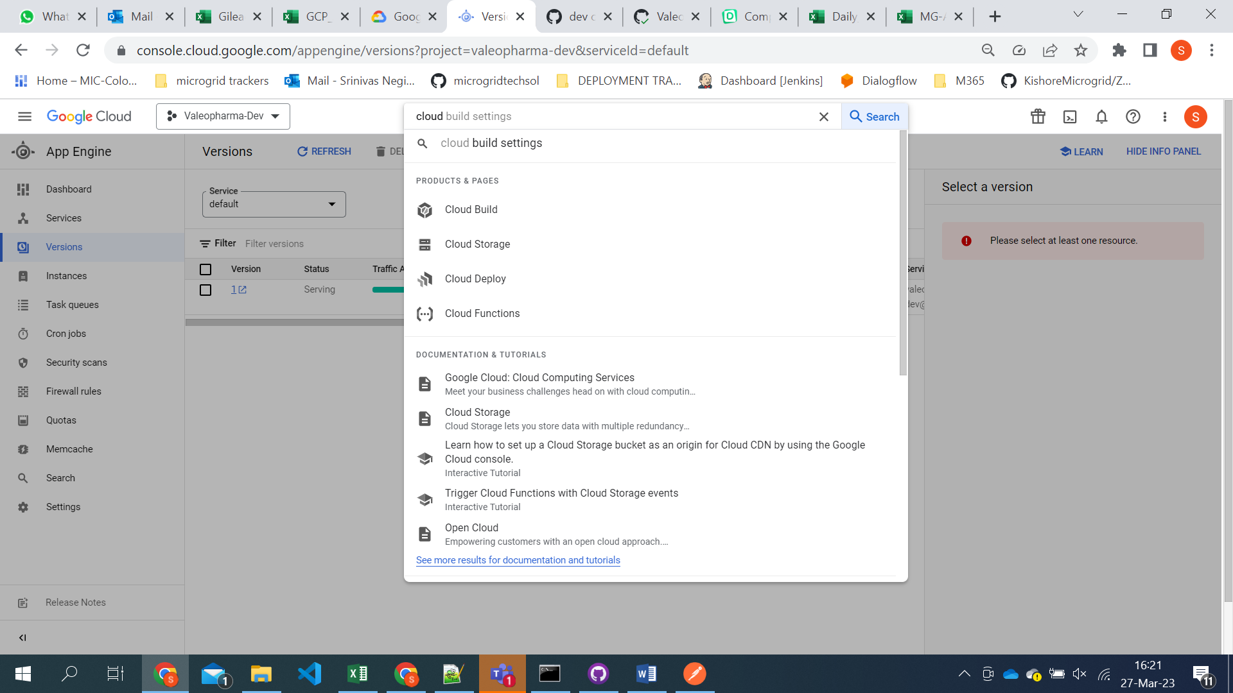

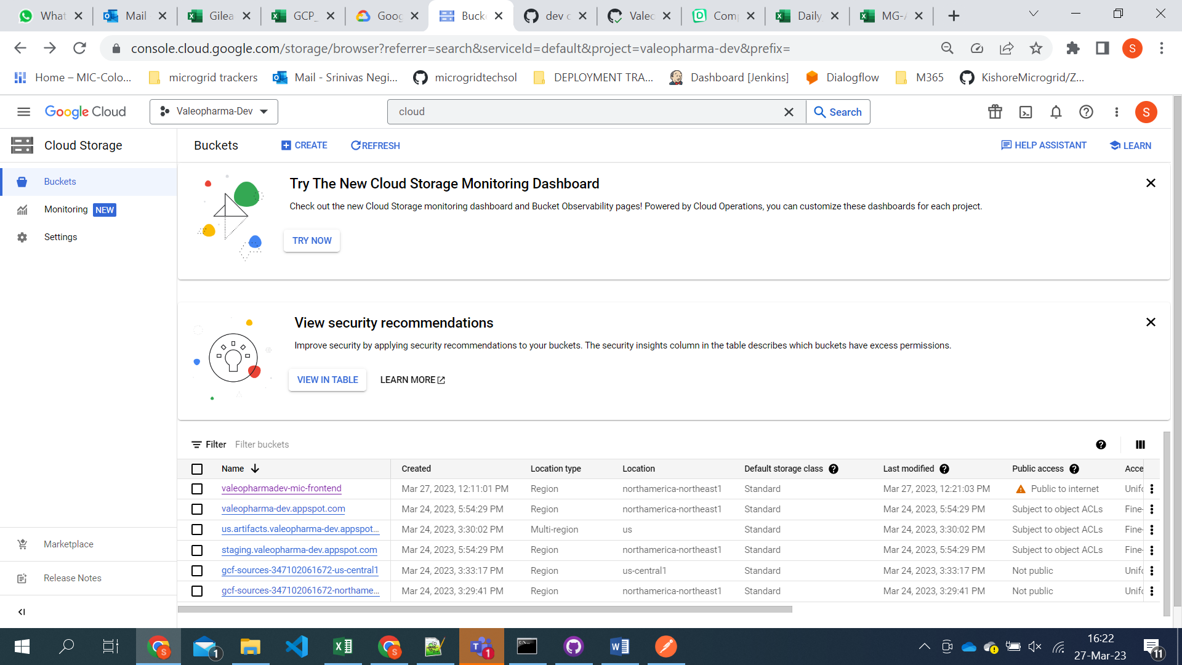

1. Click on the create.

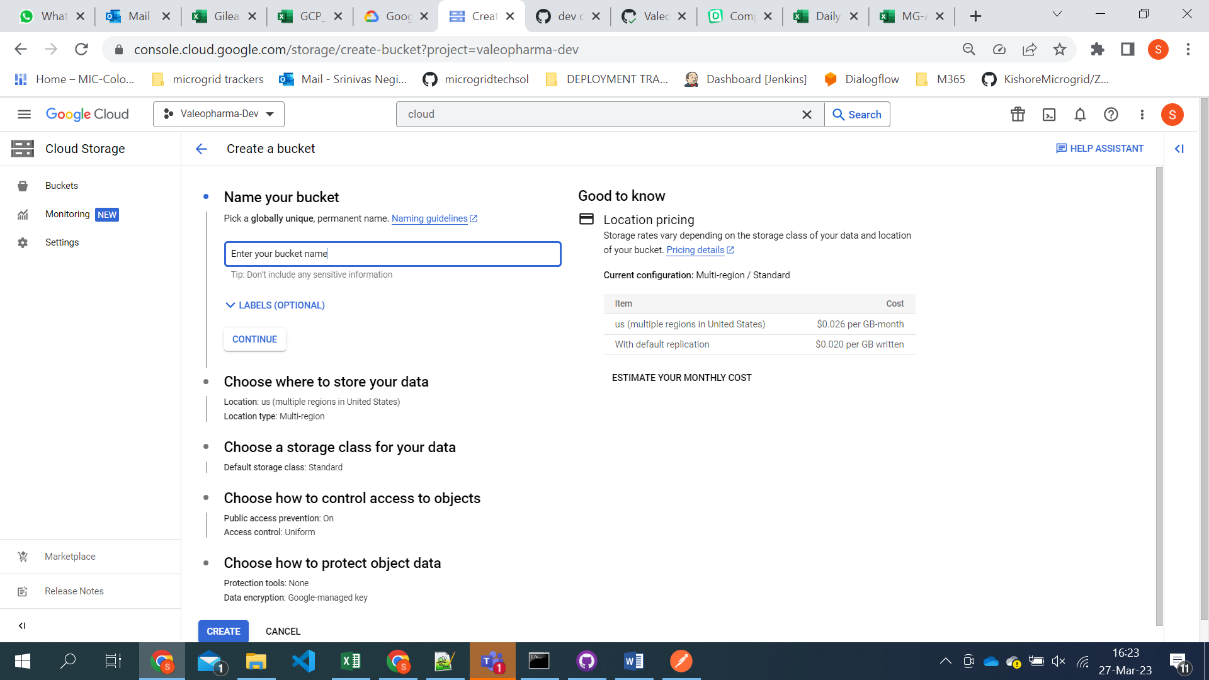

1. Select the region you want to store

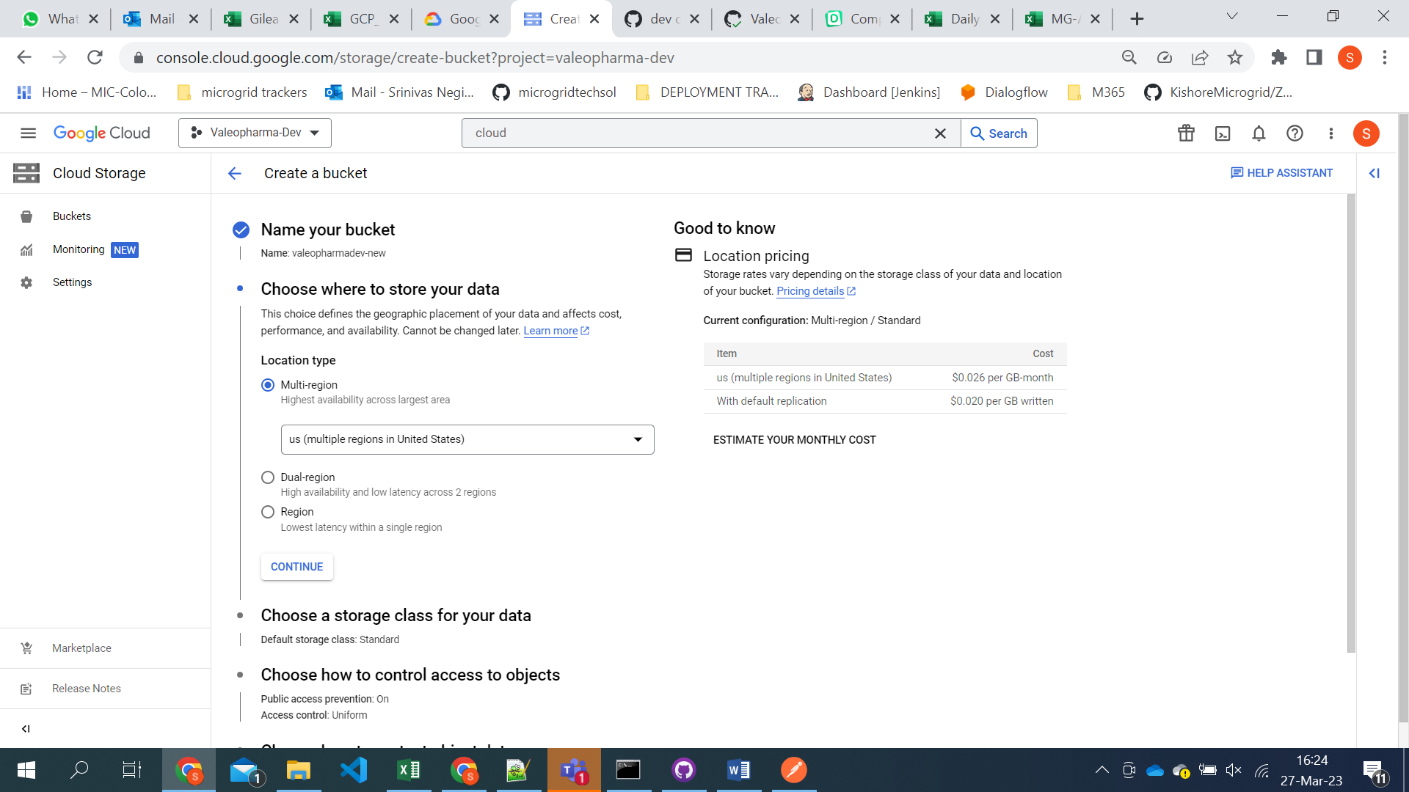

1. Choose the storage class

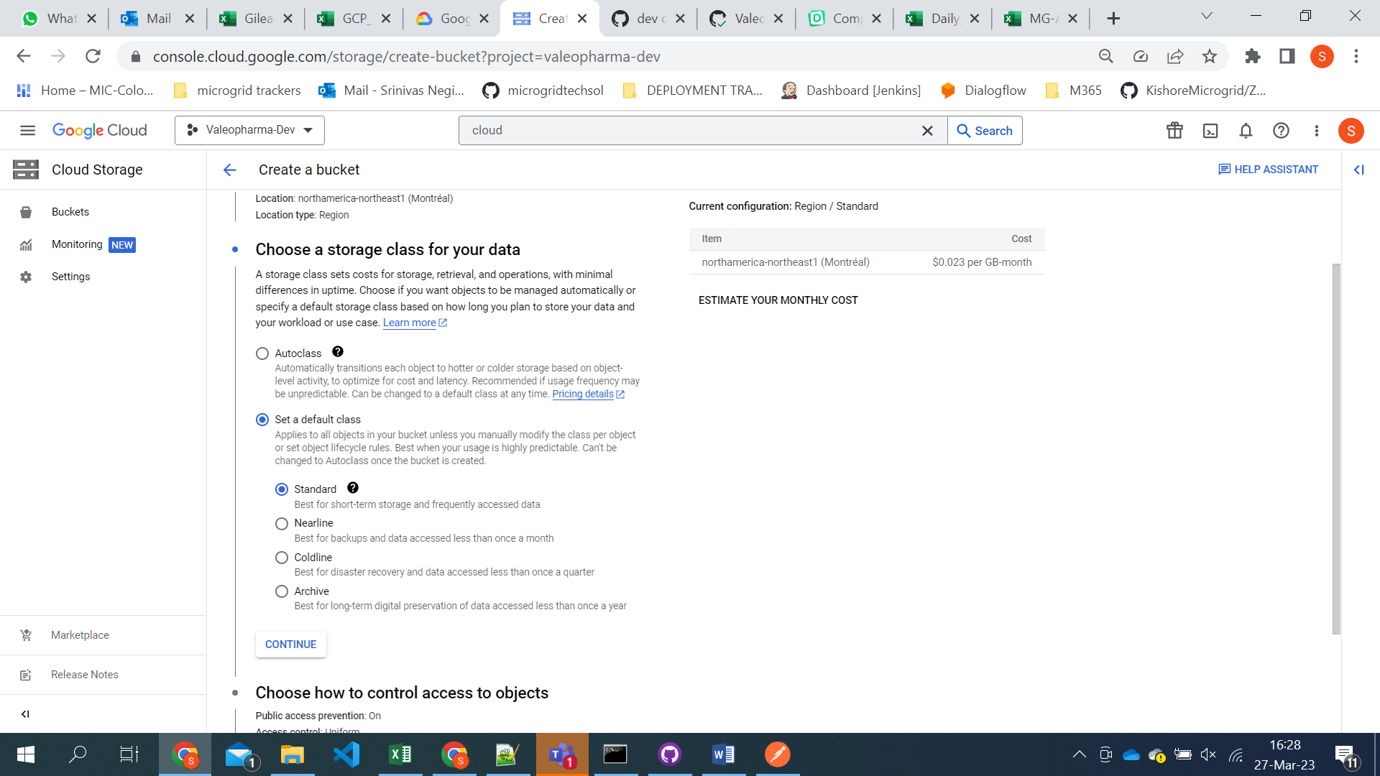

1. Click on the create button and new bucket will be created.
2. Now we need to give all users permissions for the bucket.

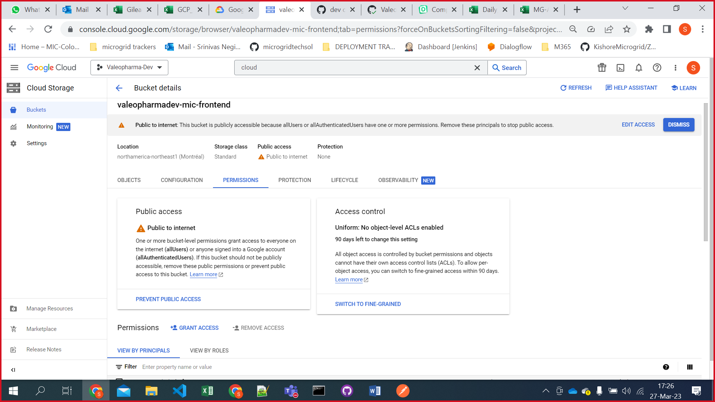

1. After bucket created click on the 3 dot at right side ang go to website settings. 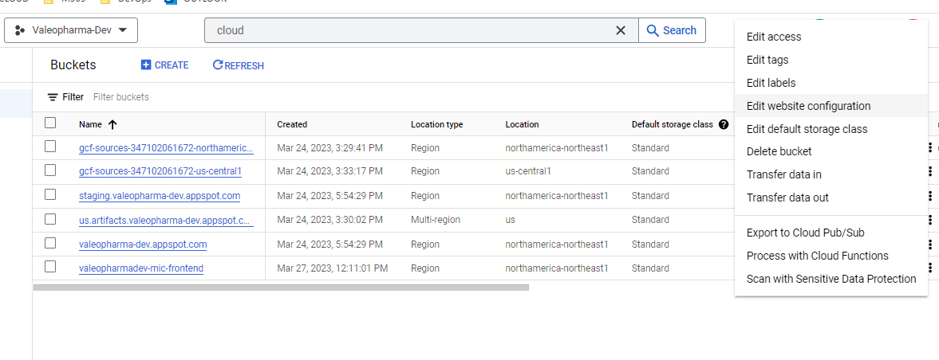
2. We need to provide index page suffix as index.html (This is for accessing chatbot other wise it will load all bucket content) 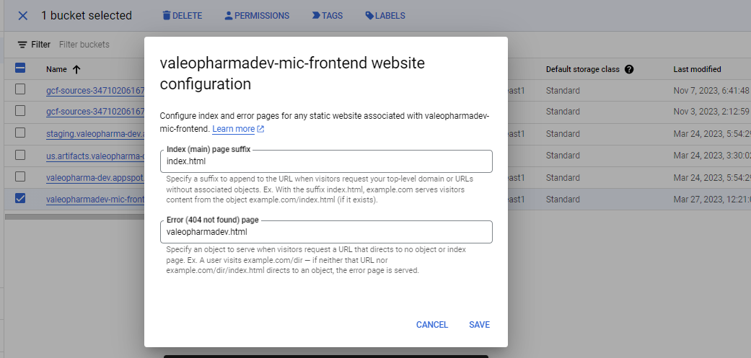

**ADDING CORS POLICY TO THE BUCKET**

1. Open cloud shell and click on open editor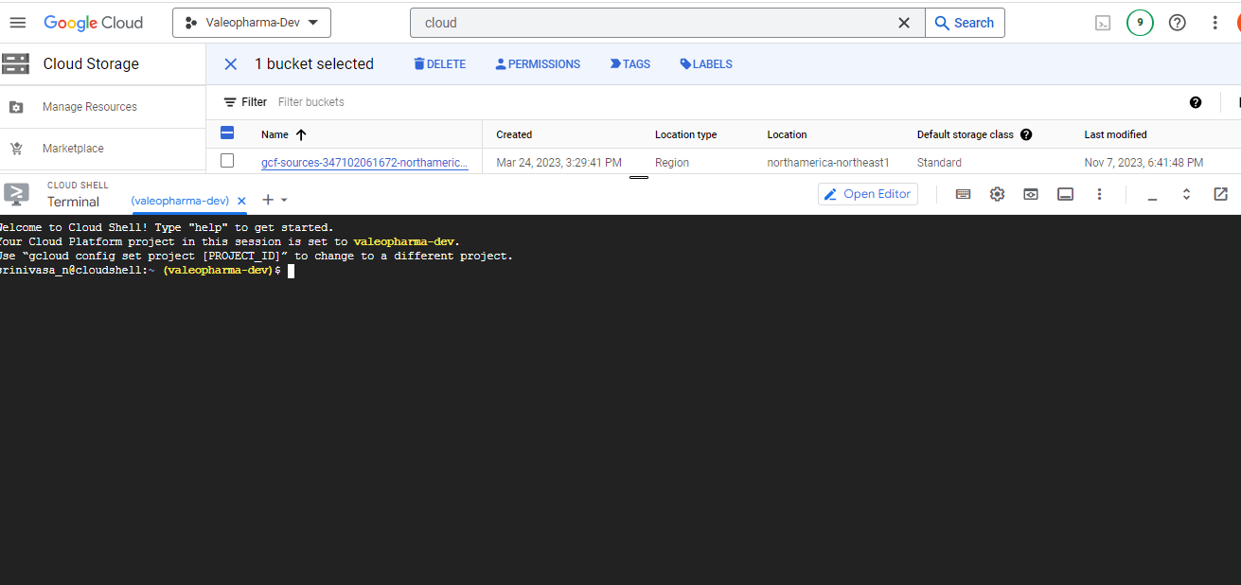
2. Click on create new file and name it cors.json file with below content

[

{

 "origin": ["*"],

 "method": ["GET", "POST"],

 "maxAgeSeconds": 3600

}

]

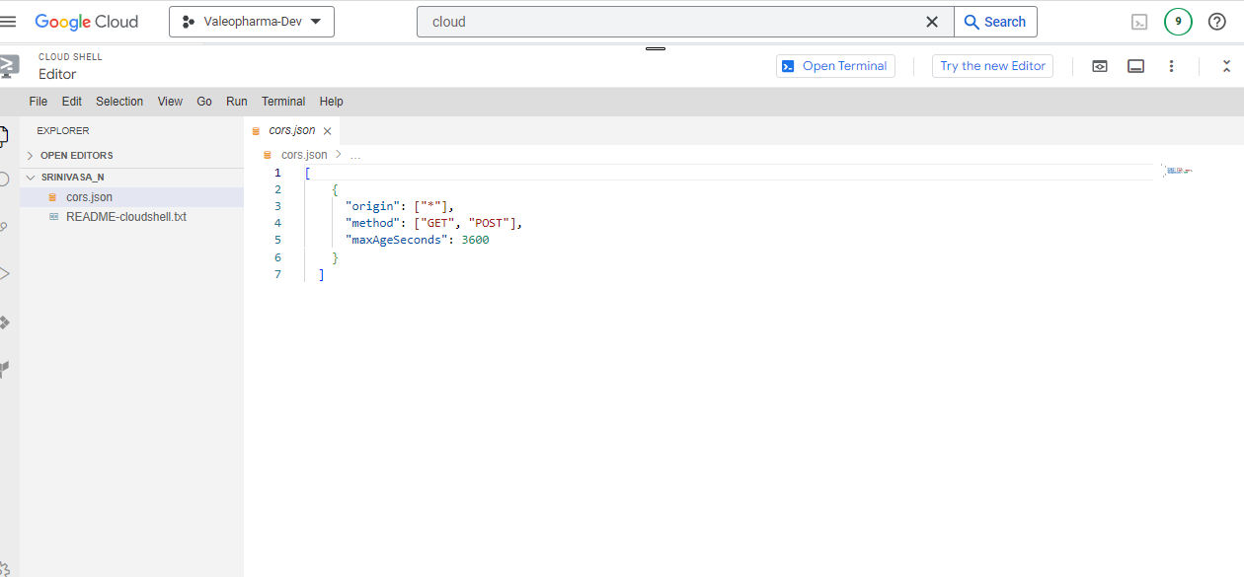save the file and click on open terminal.

1. Execute the below command to set cors policy for the bucket.

gsutil cors set cors.json [bucket url] 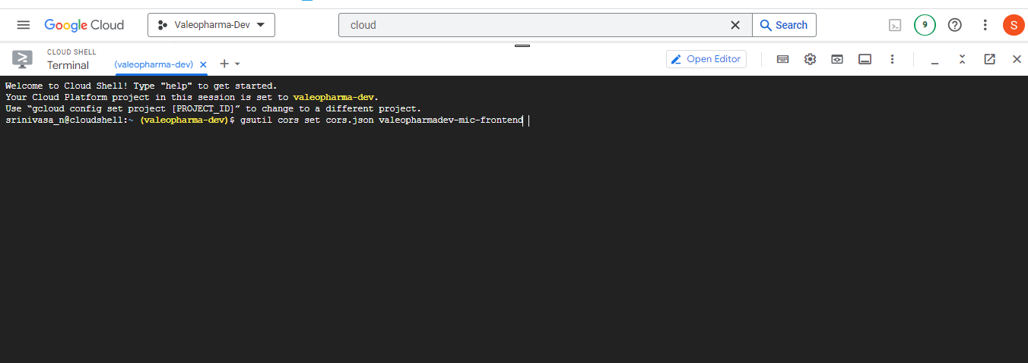

It will set the cors policy for the bucket.

1. Later we need to create a service account in IAM.
2. Go to the IAM section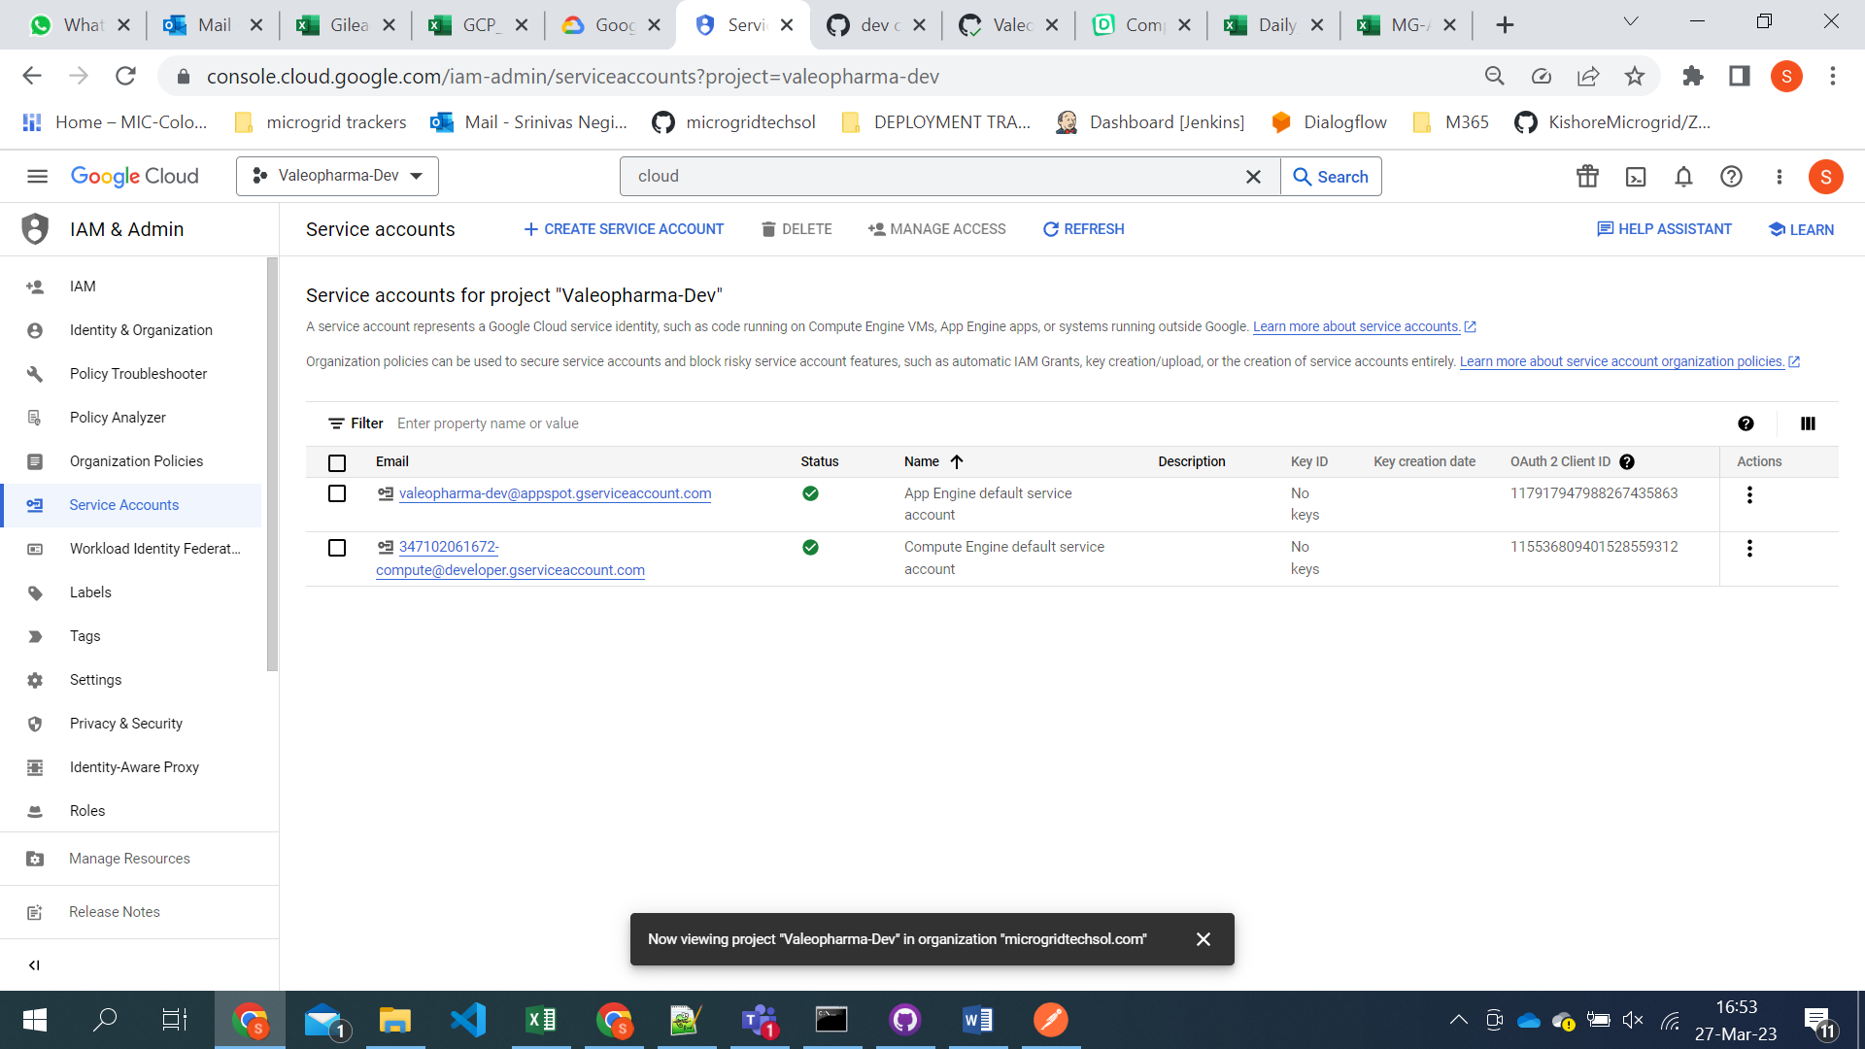
3. Click on create service account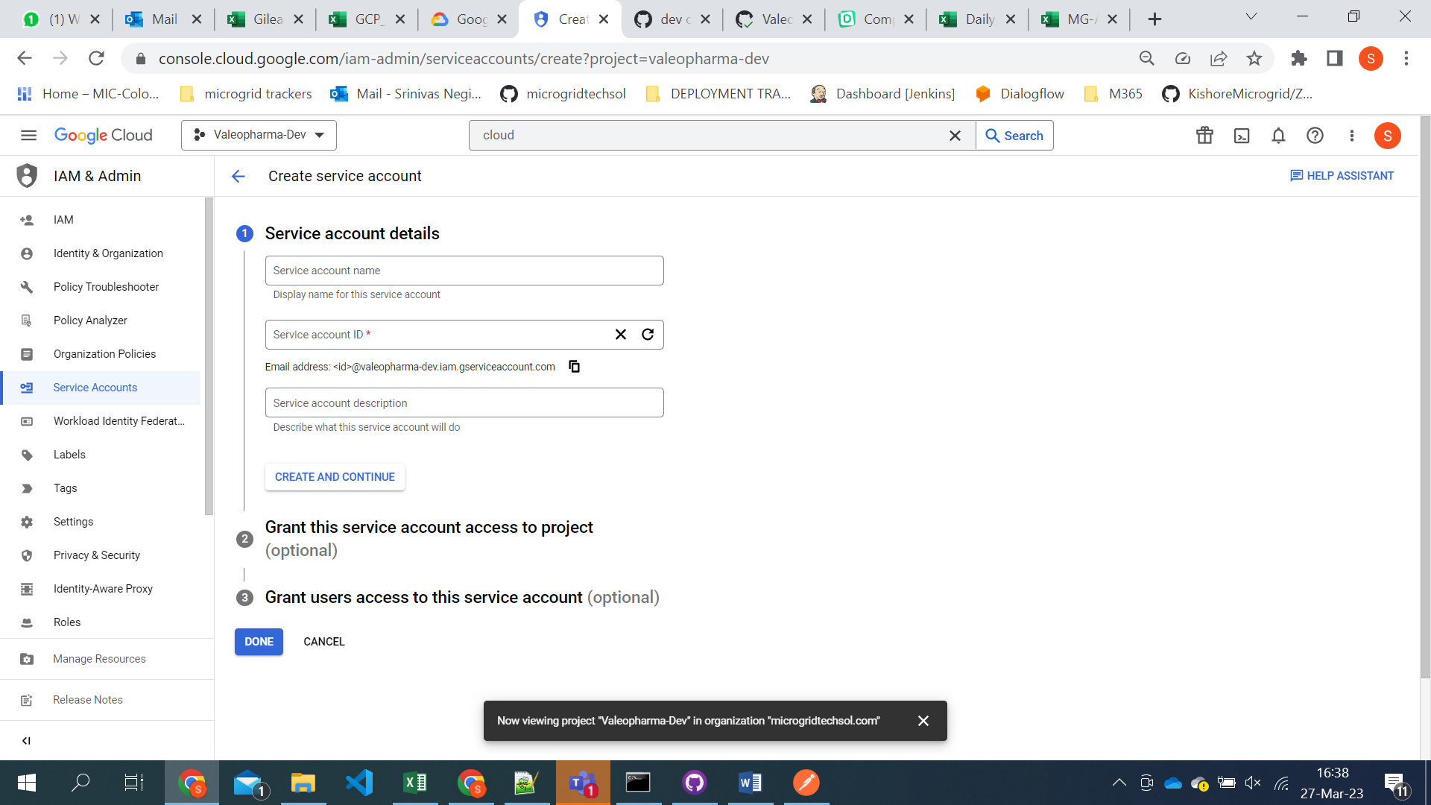

**CLOUD FUNCTION CREATION**

1. Access the cloud console and go to cloud functions service from the project.

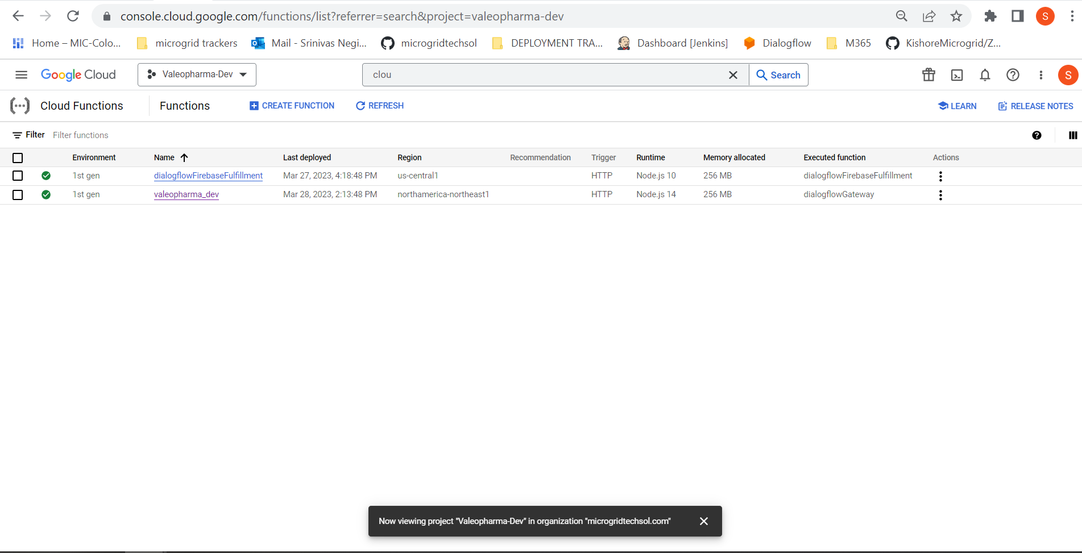

1. Click on the create cloud function.

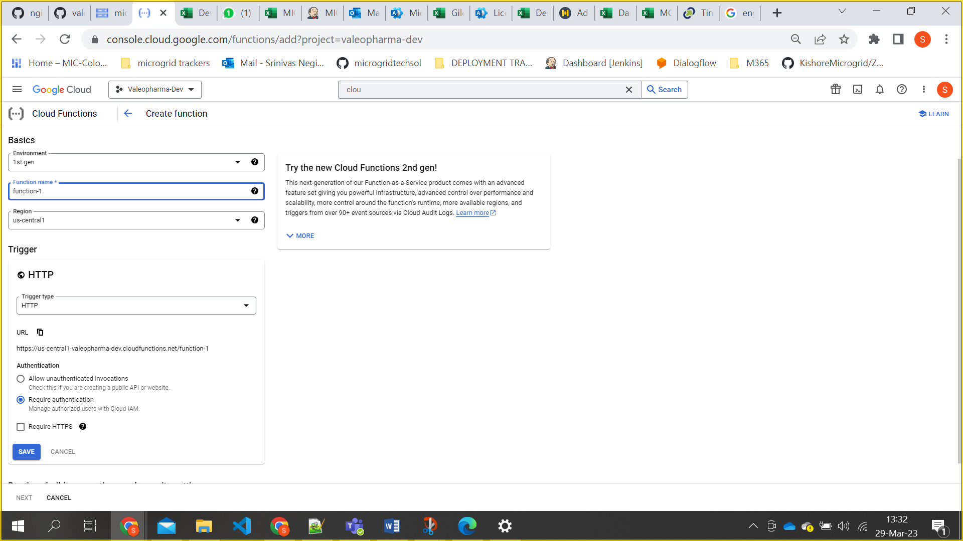

**Here** we have to follow the naming convention for Function name. [projectname_env]

Region need to selected according to project.

Uncheck the Request HTTPS and click on save button.

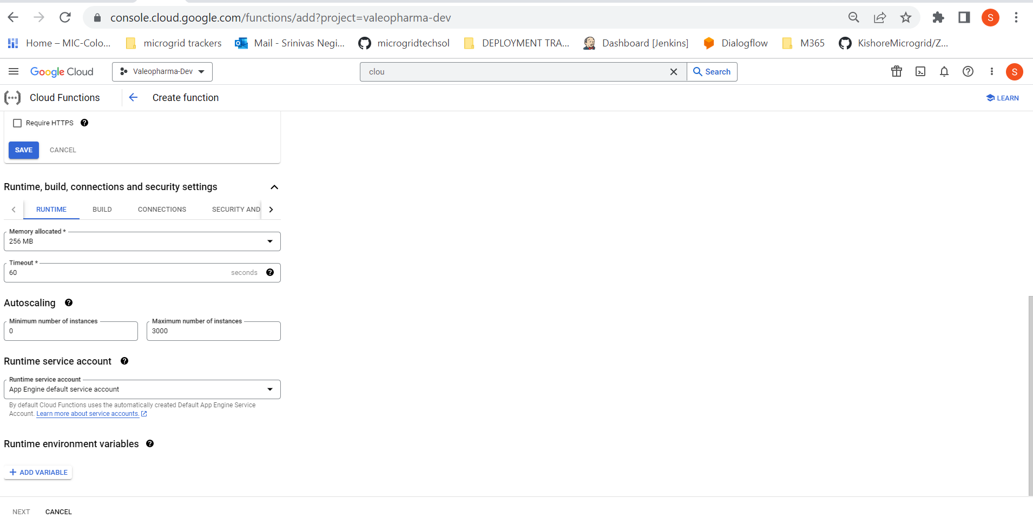

Change the maximum instance number from 3000 to 1000 and click on next button.

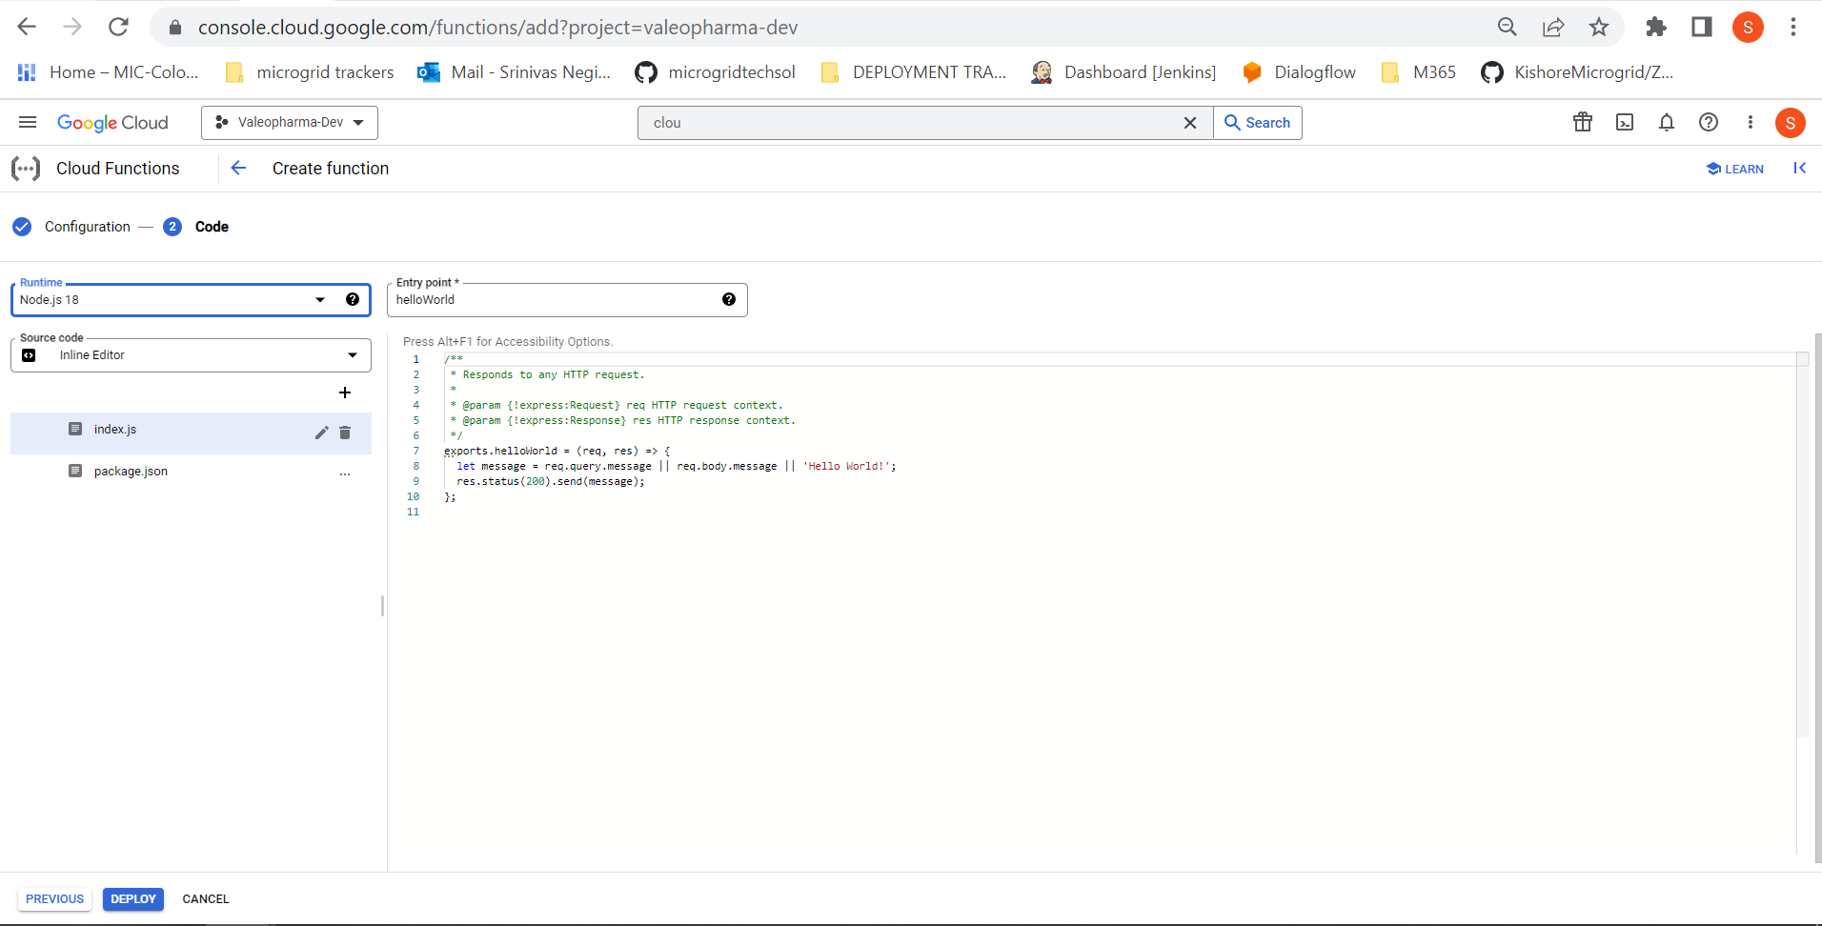

We need to select runtime that what we are using.

Entry point name is dialogflowGateway.

Generate a service account key as json file and copy the code and paste in index.js along with given code. Please find the index.js and package.json files in the folder and place them as is it is by changing project details which will be provided in key.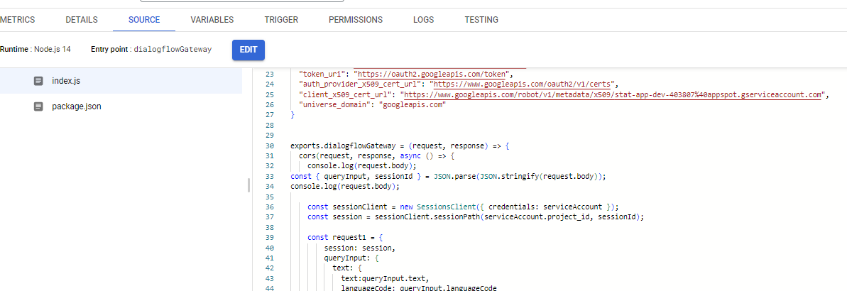

Now click on deploy.

After cloud function deployed we need to give all user permissions for the cloud function and need to give permissions for service account.

All user permissions means, Everyone can access 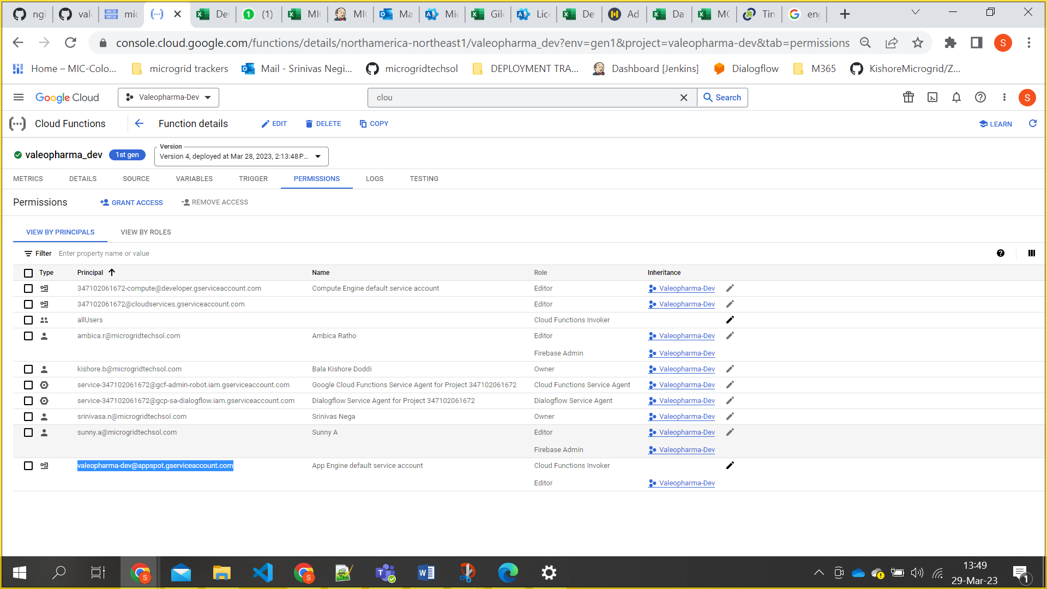

**DOMAIN CONFIGURATION**

**VM:**

If the application is accessing through Apache tomcat which is installed in vm instance it will be accessing with VM external IP and port 8080

Ex: 36.172.198.56:8080

1. Go to mic-canada-dev project and navigate to vm instance.
2. Open SSH browser and follow below commands to reach reverse_proxy_ssl.conf file.

Cd /etc/nginx/conf.d/

Vi reverse_proxy_ssl.conf

1. Add the following lines and edit the reuired fields like url and ip address.

server {

listen 443 http2 ssl;

listen [::]:443 http2 ssl;

server_name **apps.micnxt.com**;

access_log /var/log/nginx/**apps**_access.log;

error_log /var/log/nginx/**apps**_error.log;

location / {

proxy_set_header Host **apps.micnxt.com**;

proxy_pass **http://104.197.128.64:8080**;

}

ssl_certificate /etc/apache2/certs/a3348c4753956cbb.pem;

ssl_certificate_key /etc/apache2/certs/generated-private-key_MICNXT.key;

}

1. After adding restart the nginx service by using below command.

sudo service nginx restart

**CHATBOT DEPLOYMENT (Bucket)**

If the application is deployed in bucket for a chatbot we need to create load balance to the bucket.

Load balancer creation for bucket:

1. Navigate to load balancing page in network service in GCP. 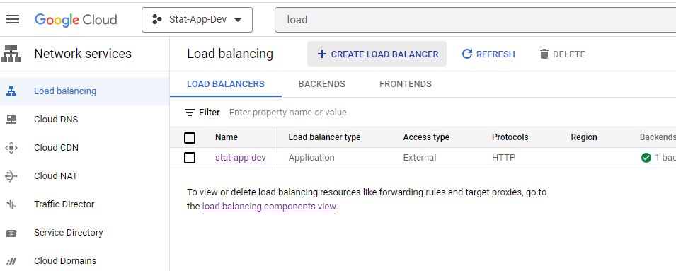
2. Click on create load balancer and select application load balancer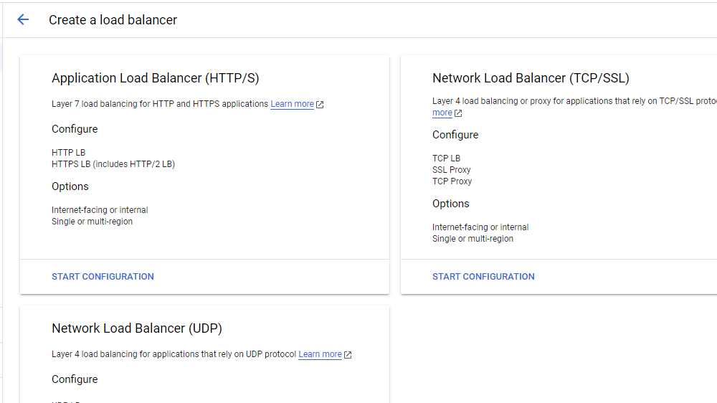

**Cloud DNS:**

1. Go to cloud dns in mic-canada-dev 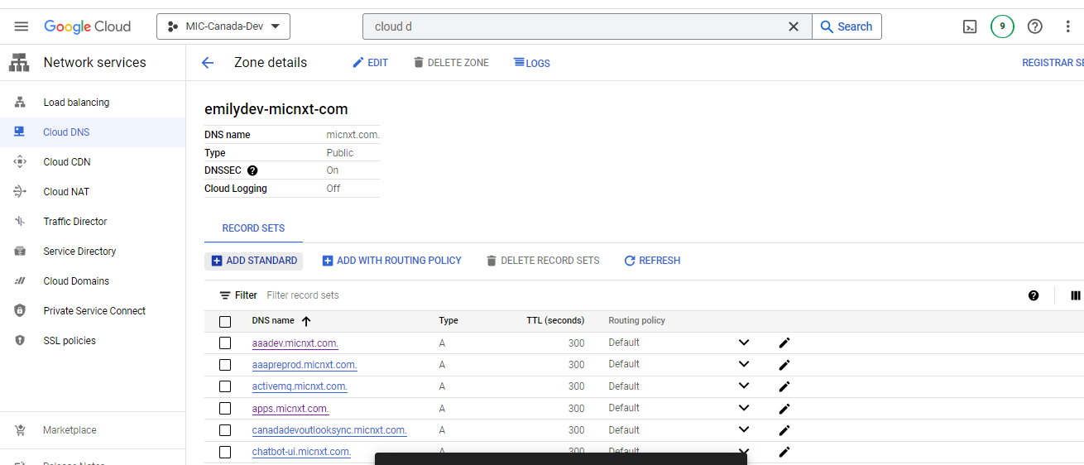
2. Click on add standard to add subdomain name
3. Add DNS name of what we required
4. IP address of mic-canada-dev VM in which nginx is there now click on create.

